**SAP TMS (Transport Management System) Tutorial**

**What is TMS?**

TMS is used to move, manage, control, copy development objects and customizing settings in an orderly fashion across SAP systems in a landscape through pre-defined transport routes (RFC Connections). The transport process basically consists of exporting of objects out of the source SAP system and importing them into the target SAP system/s. TMS Stands for Transport Management System

**Why do we need a Transport System?**

[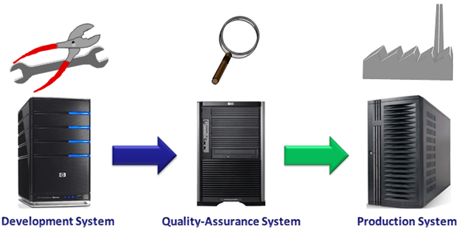](https://www.guru99.com/images/sap/2013/05/050813_0640_TransportMa1.png)

The CTS components play an important role in the overall development and customization environment. CTS stand for Change and Transport System  
  
CTS is an instrument for:

* Administering & controlling new development requests.
* Managing transports
* Recording of where and by whom changes are made
* Configuring systems landscape

**SAP System-Landscape**

[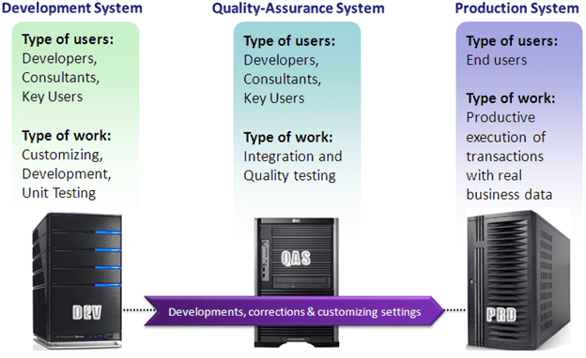](https://www.guru99.com/images/sap/2013/05/050813_0640_TransportMa3.png)

The system landscape (also known as *SAP System Group*) is the arrangement of SAP servers. Ideally, in a SAP environment, a three-system landscape is recommended. It consists of the

1. Development Server – DEV
2. Quality Assurance Server - QAS
3. Production Server - PRD.

Transport cycle in a very basic sense is the release of new Developments/ Customizing Changes from DEV which are imported in both Quality and Production systems. However, import in PRD can happen only once integration[Testing](https://www.guru99.com/software-testing.html)and quality check have been performed in QAS (and marked as checked).

**What is Customizing? How does TMS help in Customizing**

* Customizing is a process to adapt the SAP system according to the customer's need. To perform the customizing, users and consultants take help of SAP Reference Implementation Guide (IMG), which is accessible through transaction SPRO.
* Customizing is ideally done in DEV. The Transport Organizer (SE01) is used in conjunction with IMG to record and transport customized changes further.

Most of the Customizing changes (though, not all) are **client-specific**, i.e., the changes are supposed to be reflected in a particular client only and not intended for all the system clients. When the Transport Request is exported, it extracts the relevant table entries from the database of the SAP system and copies them to the transport directory. Relevant table entries are locked when the customizing transaction is being used. However, they are unlocked as soon as the changes are saved to a Transport Request.

**Repository and Development Changes**

* Apart from customizing already existing objects, new developments are also required in most of the cases. Development object is any object that is created (developed) by you in SAP system.
* A Collection of all such objects (client-specific or cross-client) is called **Repository**.
* Development is mostly done with the help of ABAP Workbench (SE80). Therefore such changes are also known as Workbench Changes.
* Examples:
  + ABAP Dictionary Objects: Tables, Domains, Data elements, etc.
  + ABAP Programs, function modules, menus, screens
  + Documents, Application defined transport-objects, etc.
* Workbench is also fully integrated with TMS, to record and transport the changes.

Most of the Workbench changes (though, not all), are **cross-client**, i.e. changes will be reflected in all the system clients of the target system. Objects transported from the source system overwrite objects in the target system that has the same names.

**Clients and the type of Data in SAP System**

* Conceptually, client is a technical and organizational independent unit, that contains its own set of data (Master Data, Application/ Operational data, Customizing Data)
* Clients create separate environments for users from different user groups or with a different purpose, within same SAP system, without actually using the different database.
* From the Technical point of view, a client is specified using 3-digit numeric ID, which also acts as the value for the table field 'MANDT', in the case of client-specific jobs.

[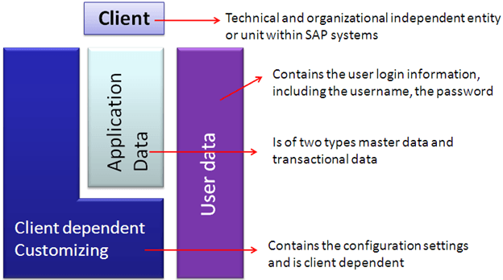](https://www.guru99.com/images/sap/2013/05/050813_0640_TransportMa5.png)

Among client specific data, there are 3 types of data:

* **User Master Data** contains the user login information, including the username, the password and the user defaults, the authorization profiles or roles, and the other useful information such as user groups, communication and so on. This data is physically present in a specific set of tables (the USR* tables).
* **Customizing Data** contains the configuration settings to customize organizational structure and the business processes for the companies implementing SAP. This data is client dependent and is stored in tables known as customizing tables.
* **Application Data** are also client dependent and normally users distinguish two types' master data and transactional data.

1. Master Data such as vendor master, material master (tables such as MARA)
2. Transactional data such as sales order, financial documents, Production Orders (POs) and so on.

**Client Customization Options**

[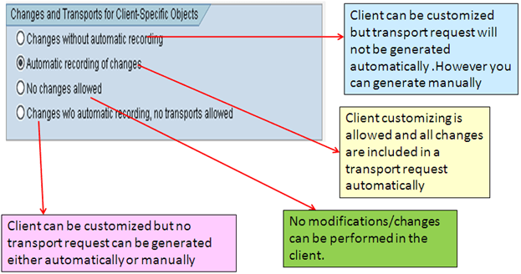](https://www.guru99.com/images/sap/2013/05/050813_0640_TransportMa6.png)